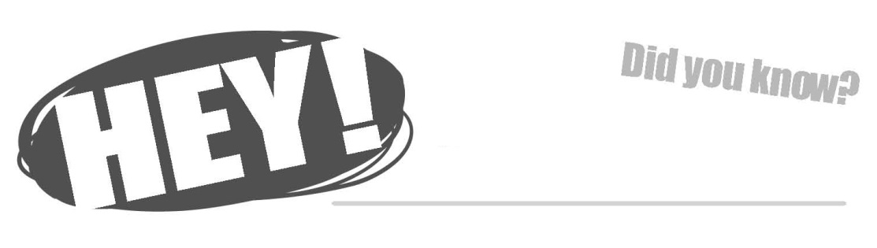

You have been recommended as a potential (school) yearbook staff member because you show one of these important yearbook traits:
- Writing skills
- Design and photography skills
- Work ethic, responsibility and dedication
- Creativity and enthusiasm
- Teamwork and effort

Know what you can get from being a yearbook staff member?
- Higher grade-point averages in English, social studies, foreign language, math and science courses than non-yearbook students*
- Better grades in high school and as college freshmen than non-yearbook students*
- Attendance at workshops and national conventions
- Skills in photography, graphic design, business, marketing, Photoshop, reporting, interviewing, writing, organization, and so much more!
- Possible local, state or national awards for individual and group work

Consider applying for yearbook
and have an unforgettable year!

Pick up an application at (location).
Applications are due by (date).

NOTE: Receiving this notice does not mean that you have been selected for yearbook. You still need to complete an application if you would like to be considered for the class.

* Based on this national study: Dvorak, Jack. High School Journalism Matters. Arlington: Newspaper Association of America Foundation. 2008.

You have been recommended as a potential (school) yearbook staff member because you show one of these important yearbook traits:
- Writing skills
- Design and photography skills
- Work ethic, responsibility and dedication
- Creativity and enthusiasm
- Teamwork and effort

Know what you can get from being a yearbook staff member?
- Higher grade-point averages in English, social studies, foreign language, math and science courses than non-yearbook students*
- Better grades in high school and as college freshmen than non-yearbook students*
- Attendance at workshops and national conventions
- Skills in photography, graphic design, business, marketing, Photoshop, reporting, interviewing, writing, organization, and so much more!
- Possible local, state or national awards for individual and group work

Consider applying for yearbook
and have an unforgettable year!

Pick up an application at (location).
Applications are due by (date).

NOTE: Receiving this notice does not mean that you have been selected for yearbook. You still need to complete an application if you would like to be considered for the class.

* Based on this national study: Dvorak, Jack. High School Journalism Matters. Arlington: Newspaper Association of America Foundation. 2008.

You have been recommended as a potential (school) yearbook staff member because you show one of these important yearbook traits:
- Writing skills
- Design and photography skills
- Work ethic, responsibility and dedication
- Creativity and enthusiasm
- Teamwork and effort

Know what you can get from being a yearbook staff member?
- Higher grade-point averages in English, social studies, foreign language, math and science courses than non-yearbook students*
- Better grades in high school and as college freshmen than non-yearbook students*
- Attendance at workshops and national conventions
- Skills in photography, graphic design, business, marketing, Photoshop, reporting, interviewing, writing, organization, and so much more!
- Possible local, state or national awards for individual and group work

Consider applying for yearbook
and have an unforgettable year!

Pick up an application at (location).
Applications are due by (date).

NOTE: Receiving this notice does not mean that you have been selected for yearbook. You still need to complete an application if you would like to be considered for the class.

* Based on this national study: Dvorak, Jack. High School Journalism Matters. Arlington: Newspaper Association of America Foundation. 2008.

