Uploading Images
Online Design’s image uploading window can always be accessed by clicking the Upload Photos link in the footer navigation, which is persistent on every screen.
The only file types that can be uploaded to Online Design are those with a .tif, .tiff, .jpg, .jpeg or .png extension. Only grayscale or RGB color images can be uploaded.
Walsworth has a 25 MB size limit on photos that can be uploaded. Very large image files could take much longer to upload, or even time out on your school’s network.
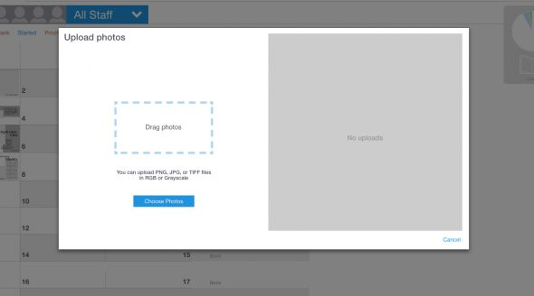
To upload images:
- Click Upload Photos in the footer navigation.
- In the window that opens, you will have two ways to select images. You can drag and drop photos on to the Drag photos area. Or you can click the Choose Photos button.
- If you click Choose Photos, navigate to the location on your computer that has the image or folder of images that you would like to upload and click to select them.
- Use the Choose album drop-down menu to pick a Photo Album for the images. You can also create a new album for these images by clicking New album, naming and saving it. The new album will automatically be selected.
- If you choose, you can type in a topic for the photo in the Add a topic text field. Click Photo topics to see the current list of topics. Adding a topic to a photo will allow you to search for a photo by topic later.
- Click Upload.
- Progress of the upload will display on the right side and will notify you when it is completed. Then you can choose to start another upload or close the window by clicking the x in the top right corner. Please note that you can’t close out of the upload window until all of your images are uploaded, or the upload process will stop.
Note that Online Design allows you to have multiple batch uploads going at one time.

