Getting to Know Page Editor
Once you are ready to begin building your yearbook spreads, it’s time to learn all about the engine that makes Online Design run – Page Editor.
To start, you need to know how to launch a Page Editor session.
Online Design provides multiple ways to open one of your spreads in a Page Editor session.

- On the home page, click the rectangles on the left side of the Ladder to open the status window for a spread. Then click the Edit Spread button. Once you have begun work on a spread, a preview of those pages will appear in those rectangles. This works the same with the Ladder in the Plan Book section.
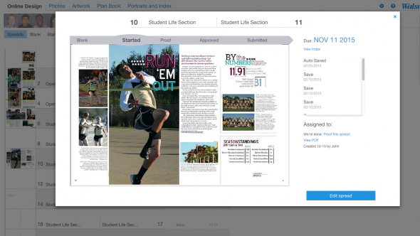

- The footer navigation includes a Recently Edited link, which pulls up thumbnails of the spreads you have most recently worked on. It also includes a menu that allows you to sort by deadline date and a link to open a window with thumbnails of all your spreads. Clicking a thumbnail will open a spread’s status window. Then click the Edit Spread button.
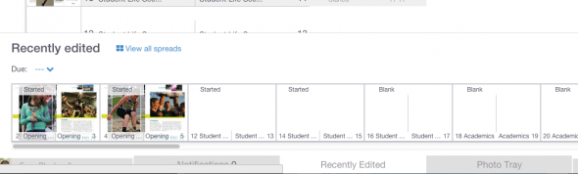
- On the home page, click the View All Spreads button located at the bottom of the Ladder. Thumbnails of all your spreads will open in a new window and they can be opened by clicking Edit Spread.

Page Editor Tools and Menus
As you begin working on pages in Online Design, you need to become familiar with Page Editor’s tools, menus and workspace.

Tools:
Online Design’s main tools appear on the left side of the screen. Here is a description of each one and how it can be used in yearbook production.

  - Undo/Redo – Remove or repeat, the most recent action you’ve taken on the page
  - Selection tool – Select an item on the page and move it around, or resize it
  - Text tool – Create text boxes by clicking and dragging across the page; this tool must also be selected to type or paste text
  - Draw tool – Draw free-form objects on the page, either angled or curved
  - Shapes tool – Opens a fly-out menu with squares, circles, polygons and starbursts; allows you to drag and drop the shapes on to the page
  - Hand tool – Allows you to pan around the page simply by clicking, holding and dragging
  - Zoom tool – Zoom in closer to an area of the page
Menus:
Many of Page Editor’s basic commands can be found in menus along the top of the screen.
File >
The File menu contains the common commands to Save and Close your spread. Save as Custom Template allows you to take an attractive spread that you would like to re-use, such as a divider page, and make it a template. View PDF gives you the option to produce a low-res PDF version of your spread for quick proofreading, or a hi-res PDF for final proofing. Restore Previous Version allows you to revert a spread back to one of its earlier versions.
Edit >
The commands under the Edit menu come in handy once you start working with type or start moving objects around on the page. Undo/Redo can be found here. Cut, Copy, Paste and Delete work just as they do in most word processing programs. It should be noted that in Page Editor, these menu functions only work with objects, not text. However, the Cut, Copy and Paste keyboard shortcuts will work for text. Check spelling will scan the spread for spelling errors.
Object >
Options under the Object menu allow you to Group and Ungroup objects, as well as Lock and Unlock objects. Convert Text to Shape is a popular design effect that allows you to turn your text into an object.
View >
The View menu will adjust the visual settings as you work around a spread. Fit to page always adjusts the view back to 100% if you have zoomed in or out. Show Grid and Show Guides display different graphical aids to help you while designing. You can have elements on the page snap to a grid or guide by using Snap to Guides, ensuring that the elements will be aligned precisely. Show Bleed Bars shows the area outside of the page shaded in blue, called the “bleed.” Text should not enter the bleed bar area or it may be trimmed off during production, while objects intended to bleed off the spread must extend to at least the outer edge of the bleed bar. Set Columns allows you to adjust the number of column guides displayed on the page.

Page Editor Palettes
The Page Editor has five palettes that appear along the right side of the screen and control more advanced settings and adjustments.

Object palette
Whenever an object, such as a photo or a shape, is selected, this palette will be open. The Object palette allows you to adjust the width and height of a shape, add a border, or rotate an object. From this palette, you can also add text on a path.

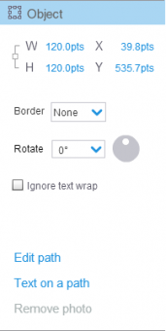

Type palette
If you are working with copy within a text box, the Type palette is where you can adjust font, type size, leading, kerning or add a drop cap. In addition, it’s from the Type palette that you can create new type styles and apply them.
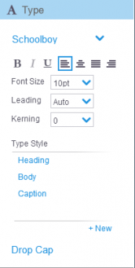

Photo palette
While selected on a photo, the Photo palette gives you a quick, easy way to see the photo’s details and launch into the Photo Effects photo editor to make adjustments if needed. From this palette, you can click the links to crop the image or add a caption that will use any tagged names associated with the photo. You can also work on more advanced techniques like a clipping path.
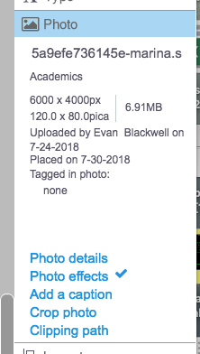

Layout palette
The Layout palette contains tools that align and distribute objects evenly on the page. Text Wrap is also located here.
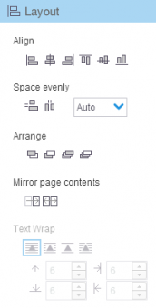

Effects palette
The Effects palette allows you to apply graphic effects like drop shadow, transparency and gradients to your page elements.

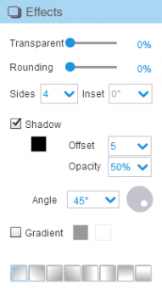

Adding Photos and Text to a Page
Once you start working in Page Editor, adding images and text to your pages can be done in a few steps.

You can start with images by using the Photo Tray, which is located in the footer navigation at the bottom of the screen.

To add a photo to a page:
1. Open a spread in a Page Editor session.
2. Click Photo Tray in the footer navigation.

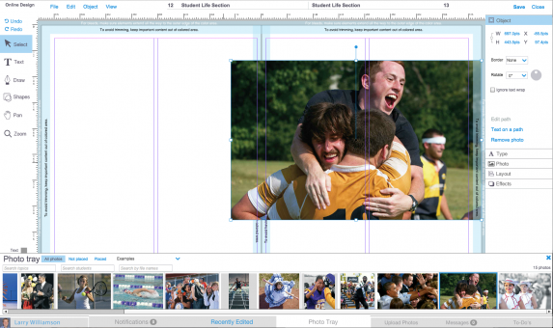

3. Thumbnails of your images will display in the Photo Tray. Use the Photo Tray menus to sort photos by whether they’ve already been placed on a page and to find images recommended for you or the spread. You can also search by topic, tagged student name and file name.
4. Once you find the image you would like to place, drag and drop it from the tray on to the page. If you have already created image windows on your spread, drag an image over the window to highlight it, then drop it into that window. Images can also be dropped into shapes that you can add to your spread from the Shapes tool.
5. Images placed in windows will likely need to be cropped. To crop an image, double-click the image and select Crop Photo.
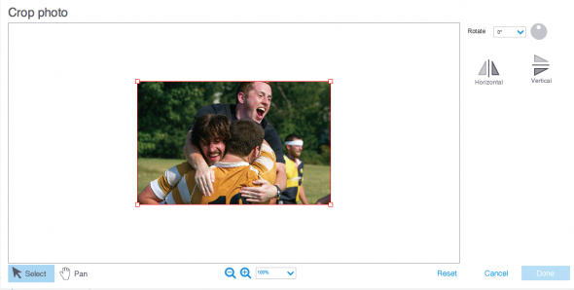

Headlines, captions and articles are all fundamental pieces of a yearbook spread. Follow these steps to add copy within Page Editor.

To add text to a page:
1. Open a spread in a Page Editor session.
2. Click the Text tool in the Tool menu on the left side of the screen.
3. Create a text box on the page by clicking and dragging your pointer arrow. Once you release, your text box will be created with a blinking cursor inside to indicate where text will appear. Note that you can also make a shape text box by clicking inside with the Text tool.

