Staff Management
Using job descriptions to organize staff lets each student know what is expected, and lets you see if every job that needs to be done is covered. Yearbook production flows much more smoothly and deadlines are easier to meet when the staff knows what part they play in the process.
Included below are the most common staff titles and their job descriptions. When preparing to assign these positions, consider the size of the staff and the talents and capabilities of each member. Advisers at smaller schools may need students to double-up on duties, while advisers at larger schools may reformat the staff organization chart yearly depending on the number of people and their skills.
For example, the staff could be managed by one editor-in-chief who oversees everything and reports to the adviser. Or, the position could be split among two, three or four co-editors who oversee various functions, and they all report to the adviser. Another format would be to have section editors at a more managerial level like co-editors, and have specific tasks delegated to assistant editors or reporters.
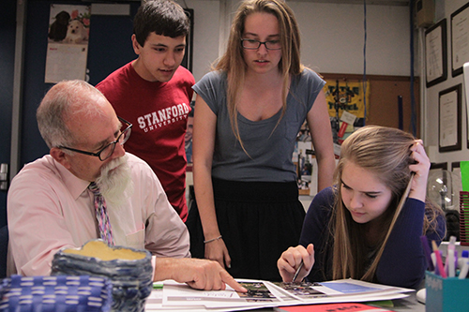
The person in the position of business manager or marketing manager could use assistants, if available, to handle the commercial ad sales, senior ad sales, book sales, budgeting and accounting. A business or marketing manager also can be at the level of a co-editor.
The best way to look at the list below might be to review the tasks, look at your staff, then decide how to organize your staff for optimum productivity.
Editor-in-Chief
The student ultimately responsible for overall development and content of the book. Among the duties:
Delegates staff assignments
Recruits staff and assigns jobs with adviser
Sets and enforces a production schedule
Edits every page and proof
Leads staff meetings
Trains and coaches staff
Decides theme, design and coverage with adviser and other editors
Plans ladder with adviser and section editors
Reports to adviser
Managing Editor
An assistant who keeps the staff operating efficiently. Among the duties:
Maintains supplies
Fills out production forms
Checks individual deadlines
Reports to editor-in-chief and adviser
Co-Editors
Sometimes used instead of editor-in-chief and managing editor. There can be more than two co-editors; section editors and business managers can be at this level. Among the duties:
Same as editor-in-chief and managing editor but are split among co-editors
Report to adviser
Copy Editor
The proofreader of all copy before pages are due, checking for style and accuracy. Among the duties:
Provides constructive feedback to improve writers’ work
Establishes copywriting styles with editor-in-chief
Edits copy for clarity, style, grammar, punctuation and spelling
Compares copy on all pages to prevent repetitiveness
Suggests coverage ideas to designers and photographers
Reports to editor-in-chief
Photo Editor
The person who assigns photographers to cover all events and stories. Among the duties:
Edits photos and captions
Ensures no photo runs twice and the same people are not photographed too often
Runs the club/sports team Picture Days
Works with professional photographer to coordinate senior and underclass portraits
Orders supplies
Sets up and maintains the image management system
Reports to editor-in-chief
Business or Marketing Manager
The leader of the book and ad sales campaigns. Larger staffs may have a team that includes a bookkeeper, sales manager, promotions manager and ad designer who report to this position. Smaller staffs may use the advertising/index editor in this position. Among the duties:
Balances the budget
Provides a monthly report of income and expenses
Organizes marketing campaigns to advertise yearbook and ad sales
Organizes additional fundraising efforts if necessary
Prepares billing statements
Writes receipts
Makes daily deposits into the yearbook account
Reports to editor-in-chief and adviser
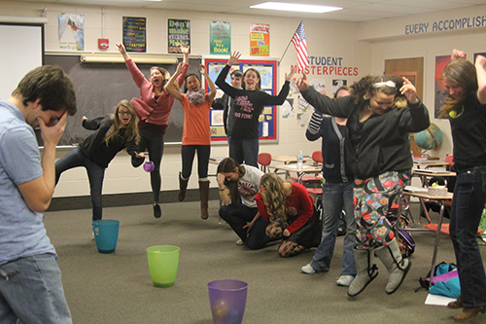
Design Editor
Creator of the layouts and page templates. Among the duties:
Organizes computer folders for templates
Trains staff on design software
Creates the style guide for design consistency
Reports to editor-in-chief and adviser
Section Editor
The person responsible for completion of all pages within his section. Among the duties:
Assigns spreads to other staff members if needed
Edits and proofreads every spread in his section
Section editors can include academics, sports, clubs/organizations, student life or people, and ads/index
Designs spreads if there is no design editor
Reports to copy editor, design editor and photo editor
Technology Director
Knows how to operate all hardware and software. Among the duties:
Ensures staff is saving text and photos in the correct format
Keeps desktops and hard drives organized
Sometimes creates, scans and manipulates all the graphics, freeing up the designers
Reports to editor-in-chief and adviser
Photographers
Take all requested photos. Among the duties:
Shoot assigned event before, during or after school
Prepare photos to use in the yearbook, including editing and filing
Write appropriate captions
Report to photo editor
Reporters
Cover and submit stories on events. Among the duties:
Conduct interviews
Cover assigned event before, during or after school
Write and submit stories by deadline
Report to section editor or copy editor

